#### Project Report On

**Book Management System**



| **Submitted By:** |  |
| --- | --- |
| **SAI SUDHAKAR** | **----------------------- K21BGB45** |
| **UTKARSH SINGH** | **-------------------------- K21BGB70** |
| **ESWAR SAI** | **-------------------------K21BGA20** |

##### ACKNOWLEDGEMENT

We take this occasion to thank God, almighty for blessing us with his grace and taking our endeavor to a successful culmination. We extend our sincere and heartfelt thanks to our esteemed guide Nidhi Arora ma’am , for providing us with the right guidance and advice at the crucial junctures and for showing me the right way.

Abstract:

Online Library Management System is a system which maintains the information about the books present in the library, their authors, the members of library to whom books are issued, library staff and all. This is very difficult to organize manually. Maintenance of all this information manually is a very complex task. Owing to the advancement of technology, organization of an Online Library becomes much simple. The Online Library Management has been designed to computerize and automate the operations performed over the information about the members, book issues and returns and all other operations. This computerization of library helps in many instances of its maintenances. It reduces the workload of management as most of the manual work done is reduced

**INTRODUCTION**

#### PROJECT AIMS AND OBJECTIVES

The project aims and objectives that will be achieved after completion of this project are discussed in this subchapter. The aims and objectives are as follows:

* Online book reading.
* A search column to search availability of books.
* Facility to download required book.
* Video tutorial for students.
* An Admin login page where admin can add books, videos or page sources.open link for Learning Websites

**BACKGROUND OF PROJECT**

###### E-Library Management System is an application which refers to library systems which are generally small or medium in size. It is used by librarian to manage the library using a computerized system where he/she can add new books, videos and Page sources.

Books and student maintenance modules are also included in this system which would keep track of the students using the library and also a detailed description about the books a library contains. With this computerized system there will be no loss of book record or member record which generally happens when a non computerized system is used.

All these modules are able to help librarian to manage the library with more convenience and in a more efficient way as compared to library systems which are not computerized.

| PROCESSOR | INTEL CORE PROCESSOR OR BETTER PERFORMANCE |
| --- | --- |
| OPERATING SYSTEM | WINDOWS VISTA ,WINDOWS7, UBUNTU |

| MEMORY | 1GB RAM OR MORE |
| --- | --- |
| HARD DISK SPACE | MINIMUM 3 GB FOR DATABASE USAGE FOR  FUTURE |
| DATABASE | MY SQL |

**SYSTEM ANALYSIS:**

# In this chapter, we will discuss and analyze about the developing process of Library Management System including software requirement specification (SRS) and comparison between existing and proposed system . The functional and non functional requirements are included

in SRS part to provide complete description and overview of system requirement before the developing process is carried out. Besides that, existing vs proposed provides a view of how the proposed system will be more efficient than the existing one.

**SOFTWARE REQUIREMENT SPECIFICATION**

**GENERAL DESCRIPTION**

PRODUCT DESCRIPTION:

Library Management System is a computerized system which helps user(librarian) to manage the library daily activity in electronic format. It reduces the risk of paper work such as file lost, file damaged and time consuming. It can help user to manage the transaction or record more effectively and time- saving

PROBLEM STATEMENT:

The problem occurred before having computerized system includes:

* File lost

When computerized system is not implemented file is always lost because of human environment.Some times due to some human error there may be a loss of records.

* File damaged When a computerized system is not there file is always lost due to some accdent like spilling of water by some member on file accidentally. Besides some natural disaster like floods or fires may also damage the files.
* Difficult to search record

When there is no computerized system there is always a difficulty in searching of records if the records are large in number .

* Space consuming

After the number of records become large the space for physical storage of file and records also increases if no computerized system is implemented.

* Cost consuming

As there is no computerized system the to add each record paper will be needed which will increase the cost for the management of library

**SYSTEM REQUIREMENTS**

NON FUNCTIONAL REQUIREMENTS

* Product Requirements EFFICIENCY REQUIREMENT

When a library management system will be implemented librarian and user will easily acess library as searching and book transaction will be very faster .

RELIABILITY REQUIREMENT

The system should accurately performs member registration ,member validation , report generation, book transaction and search

USABILITY REQUIREMENT

The system is designed for a user friendly environment so that student and staff of library can perform the various tasks easily and in an effective way.

ORGANIZATIONAL REQUIREMENT IMPLEMENTATION REQUIREMNTS

In implementing whole system it uses html in front end with php as server side scripting language which will be used for database connectivity and the backend ie the database part is developed using mysql.

DELIVERY REQUIREMENTS

The whole system is expected to be delivered in six months of time with a weekly evaluation by the project guide.

FUNCTIONAL REQUIREMENTS

1. NORMAL USER

USER LOGIN

Description of feature

This feature used by the user to login into system. They are required to enter user id and password before they are allowed to enter the system .The user id and password will be verified and if invalid id is there user is allowed to not enter the system.

Functional requirements

-user id is provided when they register

-The system must only allow user with valid id and password to enter the system -The system performs authorization process which decides what user level can acess to.

-The user must be able to logout after they finished using system.

1.1 REGISTER NEW USER Description of feature

This feature can be performed by all users to register new user to create account.

Functional requirements

-System must be able to verify information

-System must be able to delete information if information is wrong

REGISTER NEW BOOK

Description of feature

This feature allows to add new books to the library Functional requirements

-System must be able to verify information

-System must be able to enter number of copies into table.

- System must be able to not allow two books having same book id.

SEARCH BOOK

DESCRIPTION OF FEATURE

This feature is found in book maintenance part . we can search book based on book id , book name , publication or by author name.

Functional requirements

* System must be able to search the database based on select search type
* System must be able to filter book based on keyword enterd
* System must be able to show the filtered book in table view

Functional requirements

-System should be able to add detailed information about events .

-System should be able to display information on notice board available in the homepage of site

* + 1. **SOFTWARE AND HARDWARE REQUIREMENTS**

This section describes the software and hardware requirements of the system

* + - 1. SOFTWARE REQUIREMENTS
         * Operating system- Windows 7 is used as the operating system as it is stable and supports more features and is more user friendly
         * Database MYSQL-MYSQL is used as database as it easy to maintain and retrieve records by simple queries which are in English language which are easy to understand and easy to write.
         * Development tools and Programming language- HTML is used to write the whole code and develop webpages with css, java script for styling work and php for sever side scripting.
      2. HARDWARE REQUIREMENTS
* nd

Intel core i5 2 generation is used as a processor because it is fast than other processors an provide reliable and stable and we can run our pc for longtime. By using this processor we can keep on developing our project without any worries.

* Ram 1 gb is used as it will provide fast reading and writing capabilities and will in turn support in processing.

**Existing System:**

* Early days Libraries are managed manually. It required lot of time to record or to retrieve the details. The employees who have to record the details must perform their job

very carefully. Even a small mistake would create a lot of problems. Security of information is very less. Report generations of all the information is very tough task.

* Maintenance of Library catalogue and arrangement of the books to the catalogue is very complex task. In addition to its maintenance of member details, issue dates and return dates etc. manually is a complex task.
* All the operations must be performed in perfect manner for the maintenance of the library with out any degradation which may finally result in the failure of the entire system.

**Proposed System:**

To solve the inconveniences as mentioned in the existing system, an **Online Library** is proposed. The proposed system contains the following features:

* + The students will register them through Online
  + Individually each member will have his account through which he can access the information he needs.
  + Book details like authors, number of copies totally maintained by library, present available number of books, reference books, non-reference books etc. all this information can be made handy.
  + Regarding the members designation, number of books was issued.
  + Issue dates and returns of each member is maintained separately and fine charged if there is any delay in returning the book.
  + Administrator can add, update the books.

**Project Scope**

In this sub chapter, project scope will carried out what modules were contains inside the Library Management System.

For Library Management System, it is divided into online web site and library system. For my part, I was responsible for library system while the online web site was carried out by my friend Koh Yee Keat.

At here, I will describe my own part which is library system which used by librarian.

## Book system

* **Authorization and Authentication Module**

| Authorization and Authentication | | | |
| --- | --- | --- | --- |
|  | | | |
|  | | | |
| ID / Password  Checking |  |  | Password Recovery |

### This module is used by user which means librarian in the library. They need to login to the system using their id and password. In order to distinguish the user’s level, user can access to different module when successfully login. For example, only



admin level users are able to access the report module.

* + Member Maintenance Module



This module can be accessed by either librarian or library admin to maintain member’s profile or record such as search, add, edit and print ID card.

* + - Book Maintenance Module



* Publisher Maintenance Module



This module allows user to add and edit the book’s publisher. Publisher is used when register a new book.

* + Employee Maintenance Module



15

# Book Transaction Module



###### Book Transaction module is a main module in Library Management System. When member wants to borrow books, return books or they want to register lost book, it is all under book Transaction module. This module can be accessed by normal user or admin user. When member wants to borrow a book, librarian needs to scan in their member id.

After that, librarian will scan their book’s barcode id. If the book is under reservation, the book is not available to rent.

For return module, librarian just needs to scan the book’s barcode id, and confirm the rental detail with user.

16 🞆 Report Module



Report module is the main module for admin user. It is because normal user is not allowed to view the report. The report divided into 3 types. First one is transaction report which can let admin views the book transaction happen on particular date such as rental report and return report.

Top10 Report is the top rental rate’s book. Admin can filter the information based on book’s category and also filter by date in type of daily, monthly and yearly.

Activity Log File is a log which records every process in the Library Management System such as login / logout activity, register new book, new member or edit information or a member. All the activity done by every user will be record so that when system crash, admin or system admin are able to check the activity that may crash the system.

**GUI**

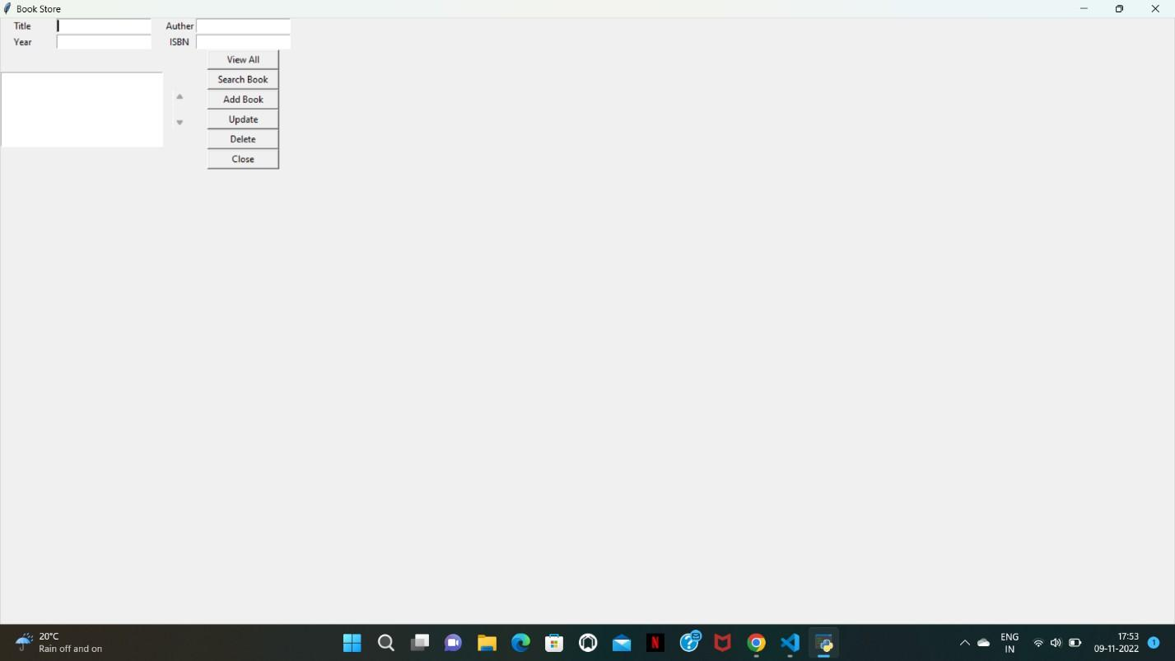

**Coding**

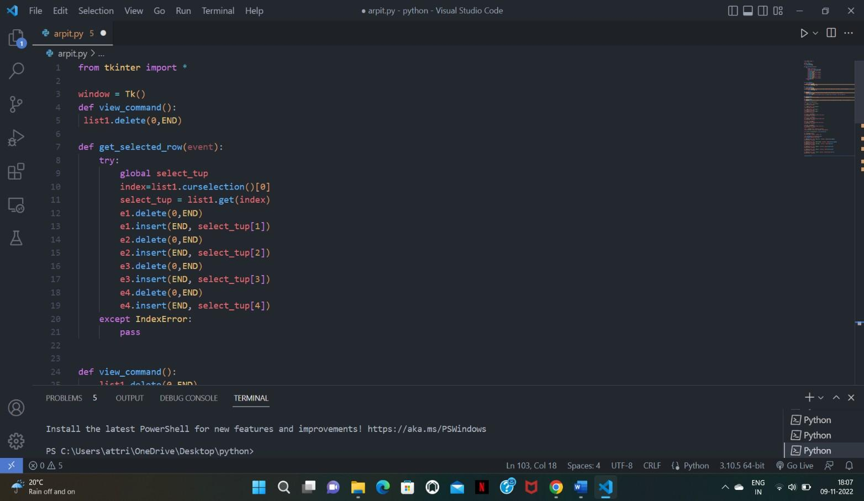

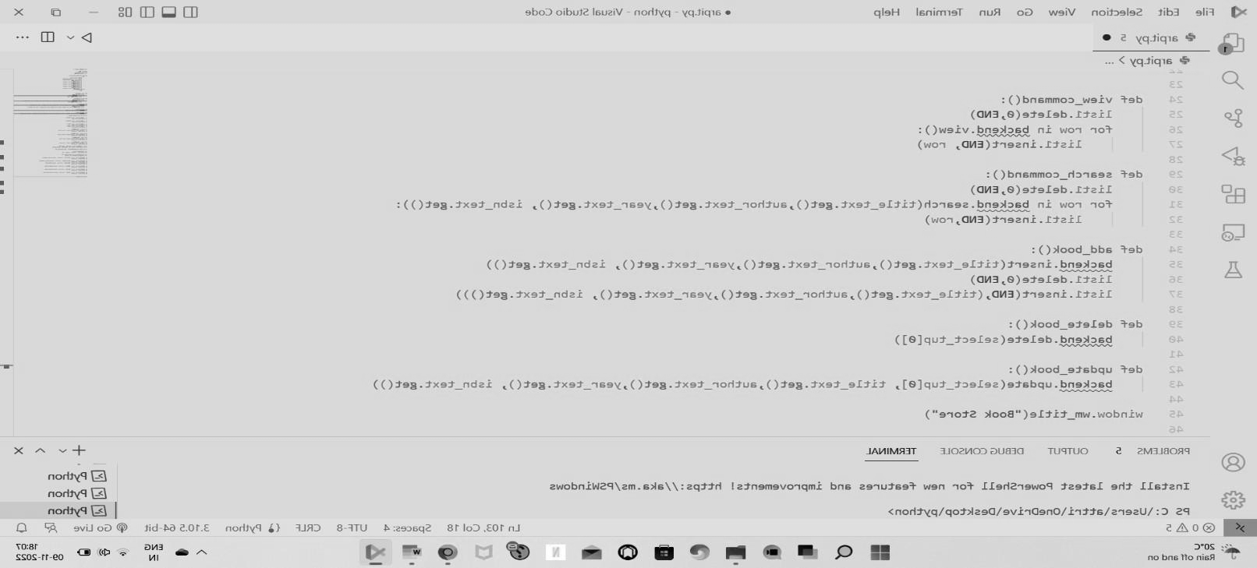

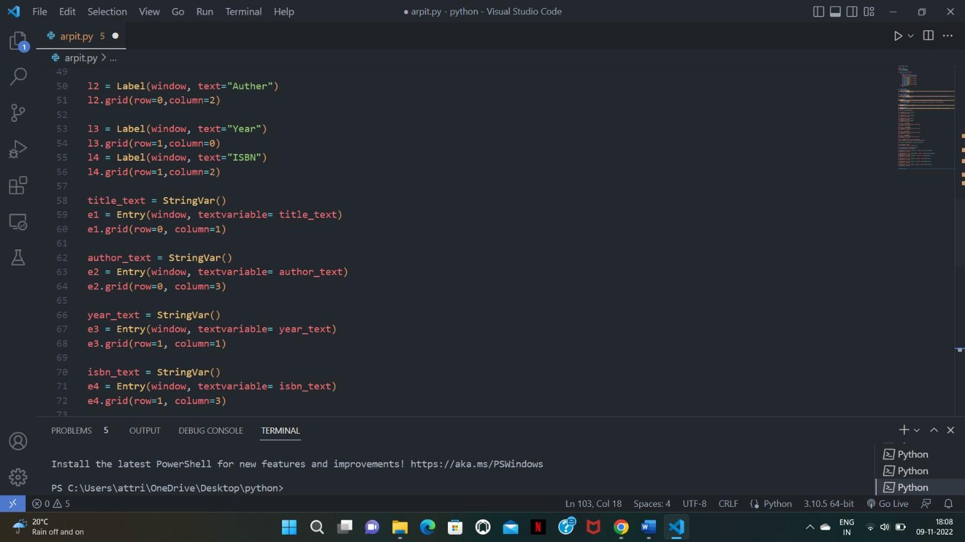

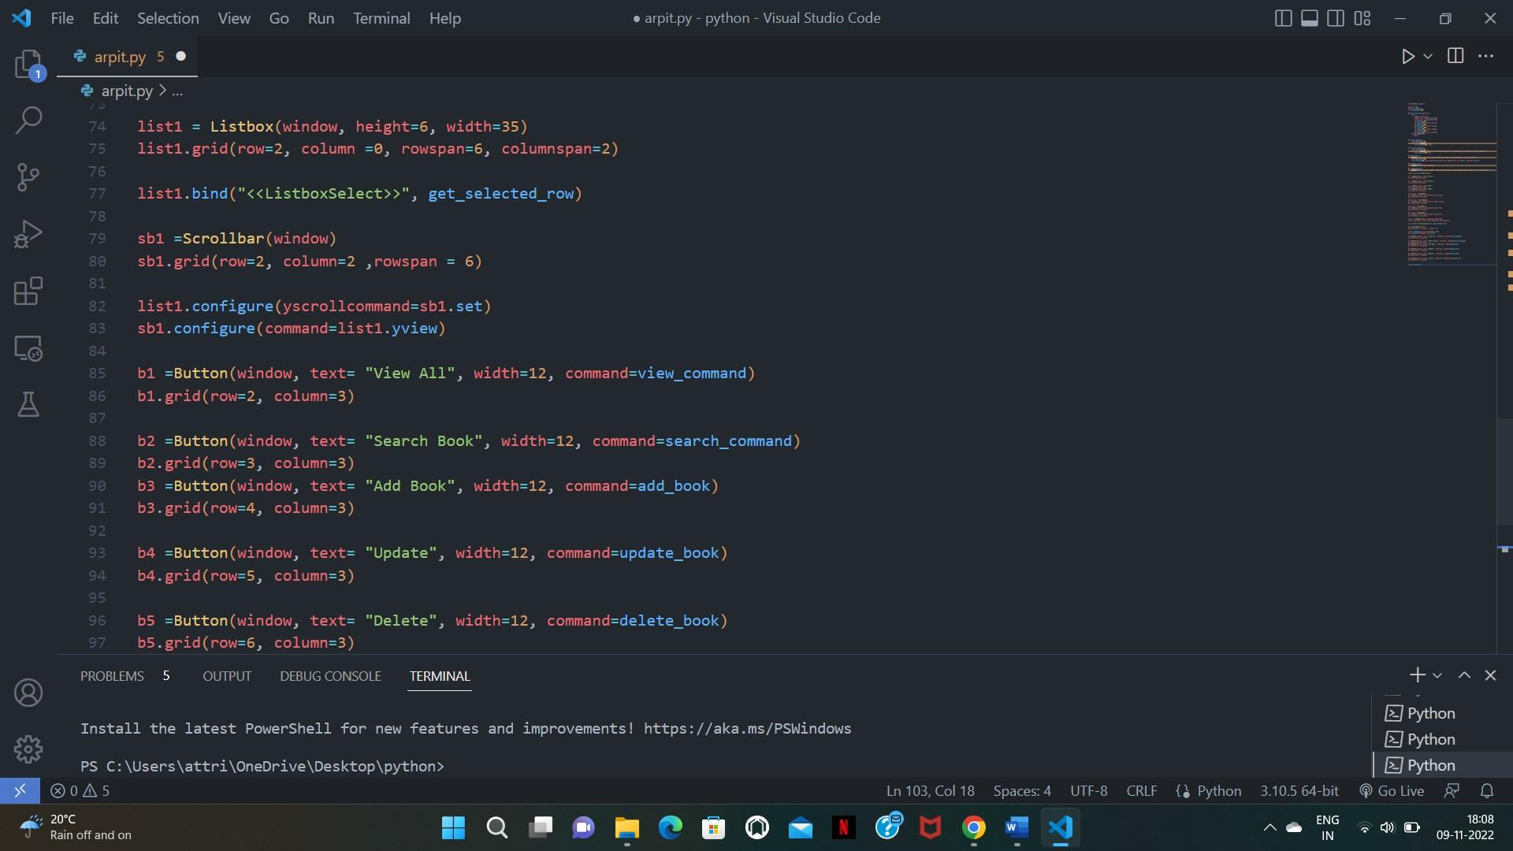

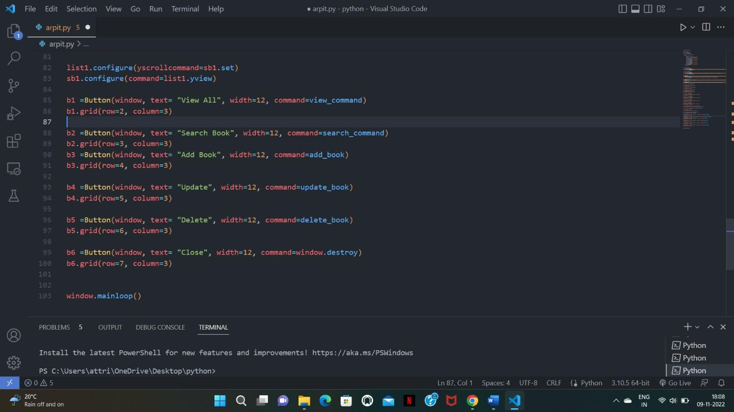

**Conclusion**

* This software is successfully done to maintain a book shop’s transaction.
* The project is completed that follow incremental model

**Reference**

* YOUTUBE
* GOOGLE
* [**https://www.google.com/search?q=book+management+system+project**](https://www.google.com/search?q=book%2Bmanagement%2Bsystem%2Bproject)
* **https://itsourcecode.com/free-projects/python-projects/book-store-management**